**Admin Log in**

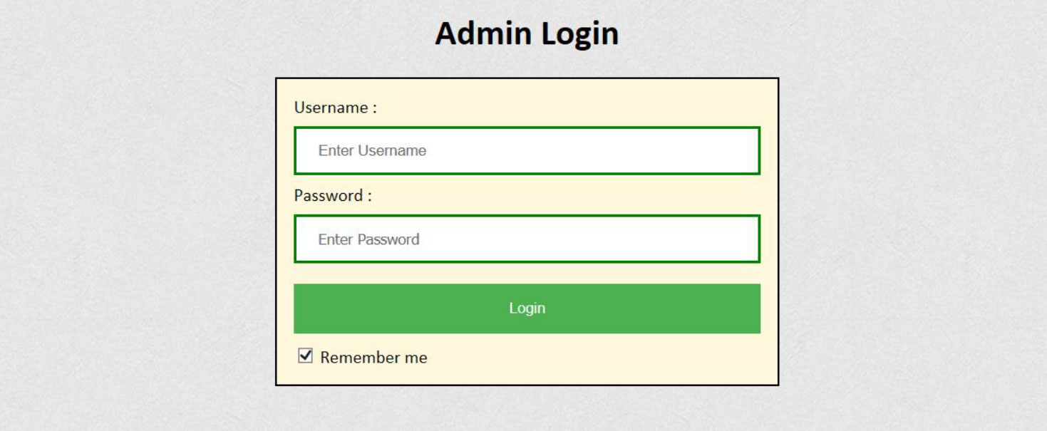

**Classes**

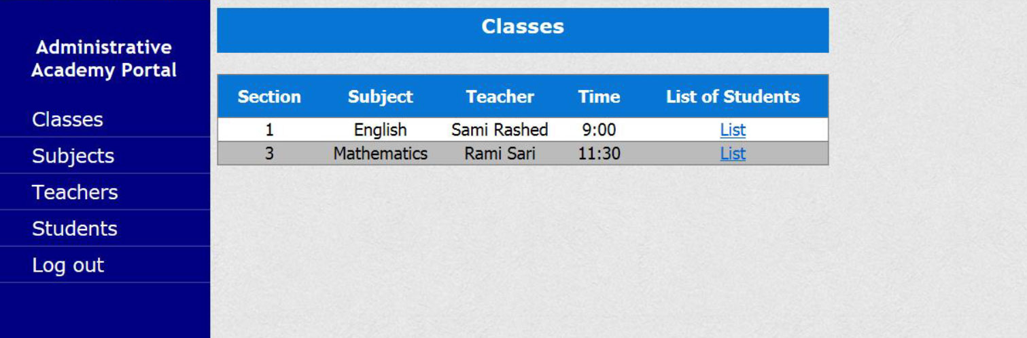

**Subjects**

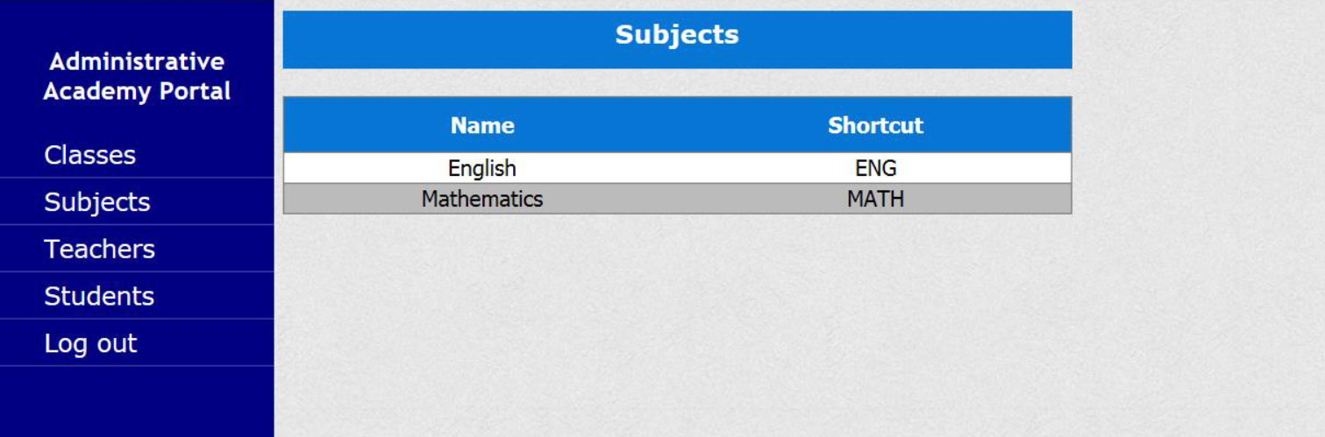

**Teachers**

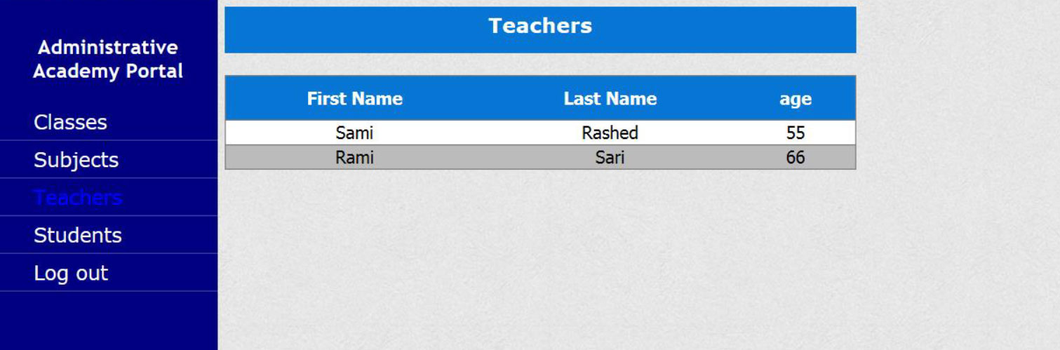

**Students**

